Books for AP Literature Spring Semester

Books you can buy through me from Prestwick House:

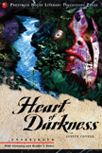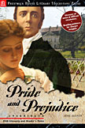
$2.50
$3.00

Heart of Darkness by Joseph Conrad Pride and Prejudice by Jane Austen

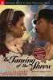
If you would like to order the books through me from Prestwick House, I’ll need $8.00 from you by Friday, January 11.
$2.50

Taming of the Shrew by William Shakespeare

Book you will need to purchase on your own (ASAP):

Things Fall Apart
by Chinua Achebe

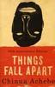

Any questions? Contact me at msmelancon@yahoo.com or melancon@fultonschools.org

